INSPIRED BY DJS, BUILT FOR LIFE
Sennheiser’s new HD 250BT headphones deliver a thrilling on-the-go audio experience

Wedemark, October 1, 2020 – Sennheiser’s new HD 250BT headphones deliver a thrilling audio experience with dynamic bass, state-of-the-art Bluetooth connectivity and a durable design that is built to take on life’s adventures. Boasting a 25-hour battery life and advanced codec support at an affordable price, the new HD 250BT lets listeners enjoy Sennheiser’s superior audio anytime and anywhere.

Sennheiser’s new HD 250BT headphones are equipped with the audio specialist’s famed transducer technology. Support for high-quality audio codecs such as AAC and aptXTM as well as rock-solid Bluetooth 5.0 connectivity ensure remarkable wireless audio quality with dynamic bass for music enjoyment on the go. For listeners seeking to personalize their audio experience, the Sennheiser Smart Control app’s intuitive equalizer makes it possible to tailor the sound experience according to individual taste. Meanwhile, aptX™ Low Latency perfectly synchronizes audio with on-screen action while watching videos.

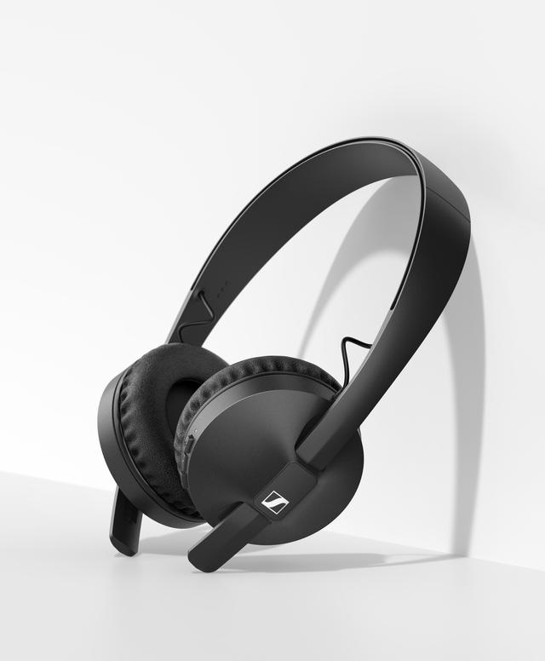

Sennheiser’s new HD 250BT headphones deliver a thrilling on-the-go audio experience at an affordable price

“With remarkable performance and advanced features at an accessible price point, our new HD 250BT truly punches above its weight to enhance the everyday audio experience,” said Jermo Köhnke, Product Manager at Sennheiser. “These entry-level headphones offer a host of premium features that deliver a nightclub-worthy sound experience – wherever you are.”

Whether listening to music on the road for hours at a time, watching videos or taking calls via the built-in microphone, the HD 250BT’s outstanding 25-hour battery life ensures the headphones keep pace with the busiest lifestyles. Featuring a rugged design, soft, noise-isolating ear pads and intuitive controls, the HD 250BT is built to take on life’s adventures.

The Sennheiser HD 250BT is available in selected markets for 69 EUR (MSRP).

About Sennheiser
Founded in 1945, Sennheiser is celebrating its 75th anniversary this year. Shaping the future of audio and creating unique sound experiences for customers – this aim unites Sennheiser employees and partners worldwide. The independent family company, which is managed in the third generation by Dr. Andreas Sennheiser and Daniel Sennheiser, is today one of the world’s leading manufacturers of headphones, loudspeakers, microphones and wireless transmission systems. In 2019, the Sennheiser Group generated turnover totaling €756.7 million. www.sennheiser.com

Global Press Contact
Sennheiser electronic GmbH & Co. KG
Jacqueline Gusmag
Communications Manager Consumer
T: +49 (0)5130 600-1540
jacqueline.gusmag@sennheiser.com

